**PRT 452 Assignment 1**

# **Yuze Li s306890**

# Q1.

Github link: <https://github.com/YuzeLi/PRT-452-Assignment-1>



# Q2.

All files uploaded to Github.

<https://github.com/YuzeLi/PRT-452-Assignment-1/tree/master/src>

# Q3.

In this parts, I have searched a lot of resource, and also learned what is Bad Smell.

Below I will present 5 examples and classify them to Bad Smell.

1.

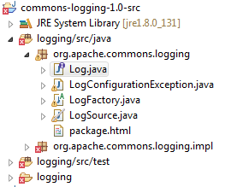

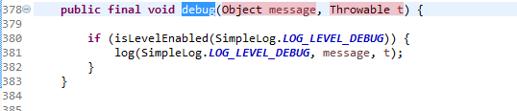

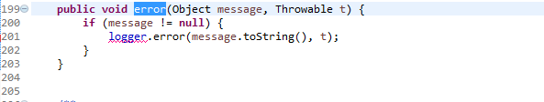

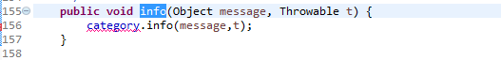

The same field (Object message, Throwable t) in those classes. Data items like children. They prefer to stay together and you can often see them in many places. In my opinion, this one is Date Clumps. Other ways, you should have a new object for them.

2.

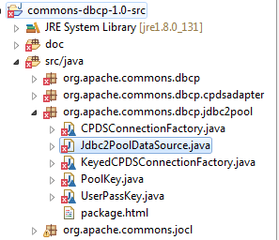

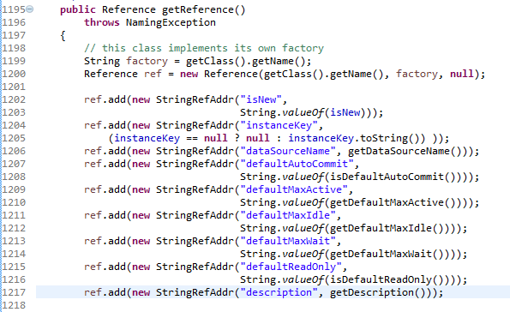

Use one method to get another object, and then through this object to get another object or its method. If one of the objects has a problem, it will affect the follow-up results. So this one classify Message Chains.

3.

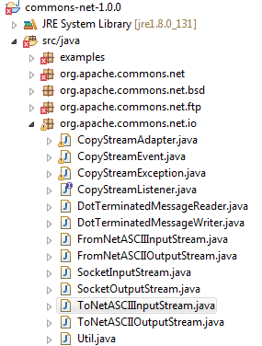

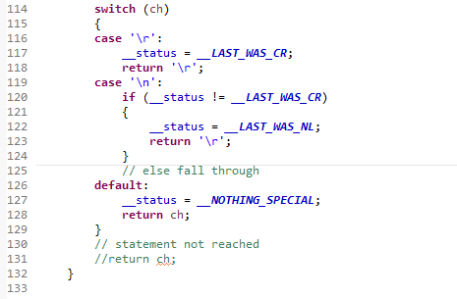

The problem with the switch statement is that you will find that the same switch statement is scattered in different places. If you want to add a new case clause to it, you must find all and modify them.

4.

<https://issues.apache.org/jira/browse/NET-242?jql=project%20%3D%20NET%20AND%20status%20in%20(Resolved%2C%20Closed)%20AND%20text%20~%20%22delete%22%20ORDER%20BY%20key%20DESC>

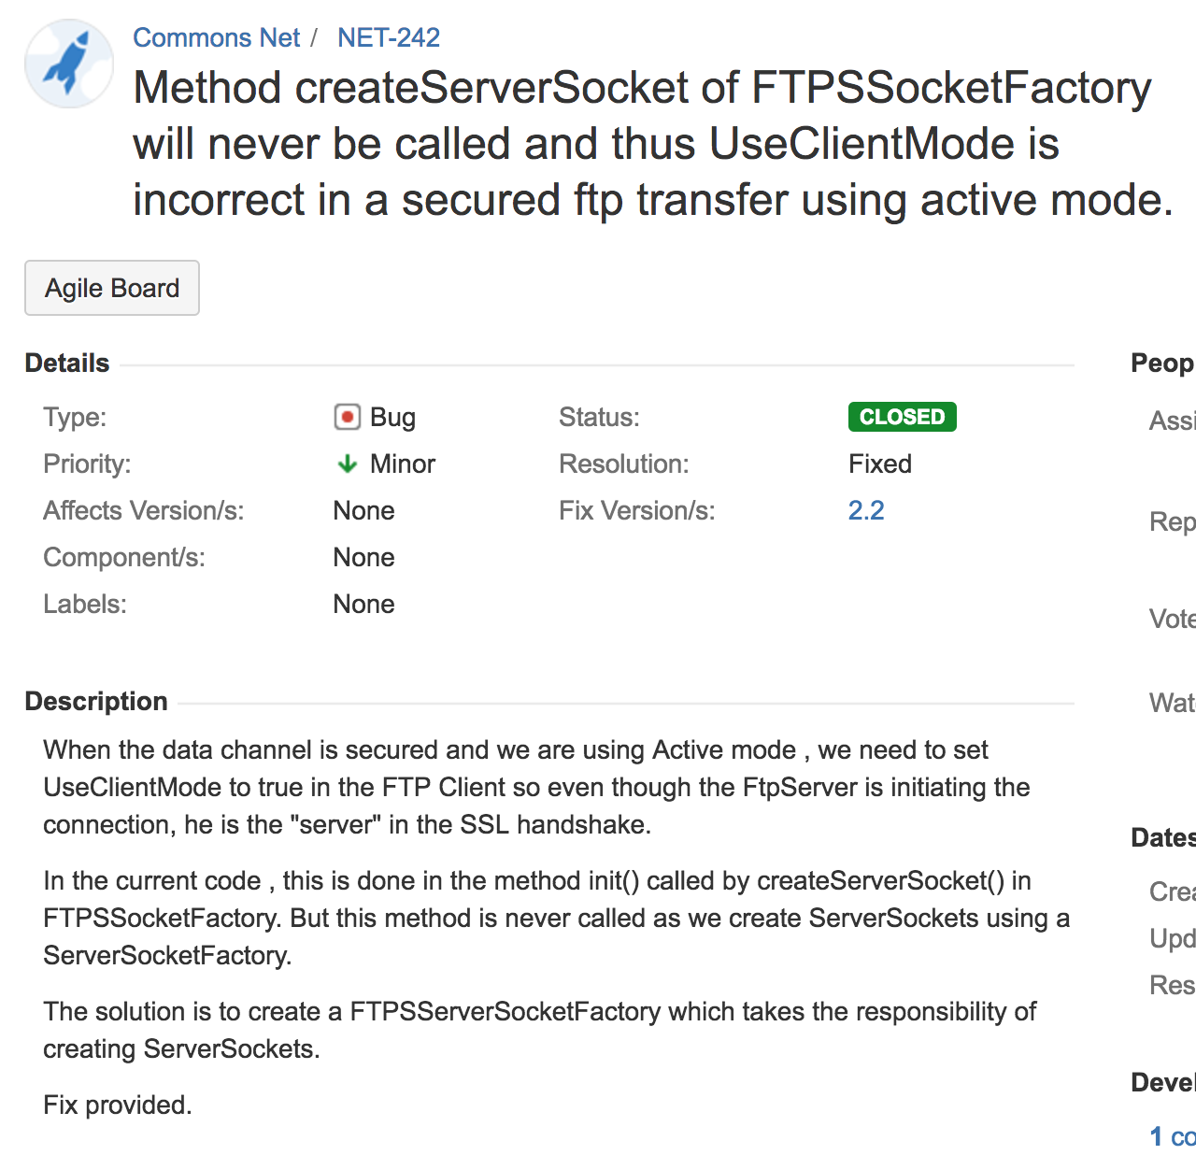

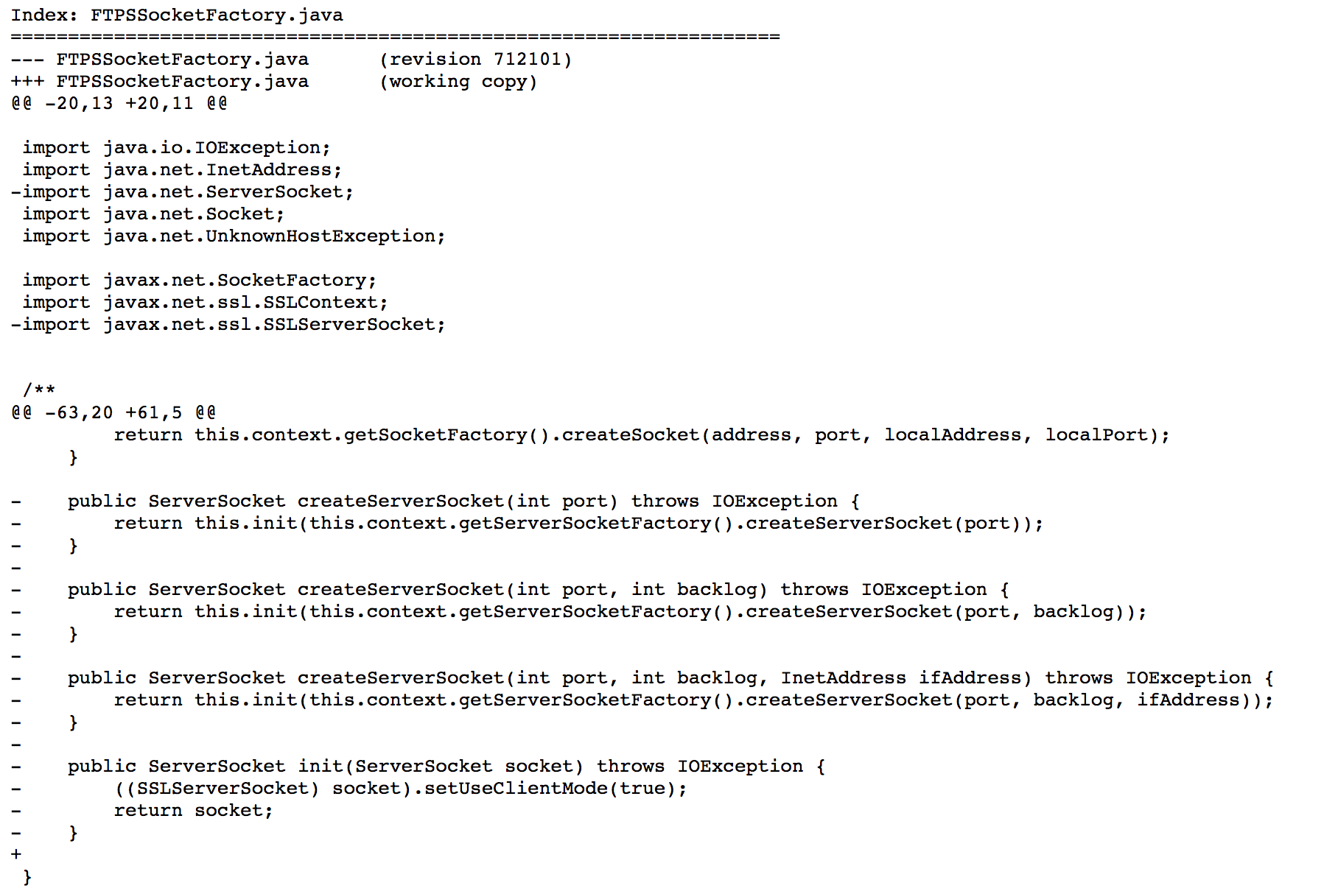

This one is Speculative Generality. If all the part will be used, it is right. if not, it may not good. Do not use the part that will only block your way. If there have, just move or delete it.

5.

<https://issues.apache.org/jira/browse/NET-621?jql=project%20in%20(DBCP%2C%20IO%2C%20DBUTILS%2C%20LOGGING%2C%20NET)%20AND%20text%20~%20%22remove%20unnecessary%22>

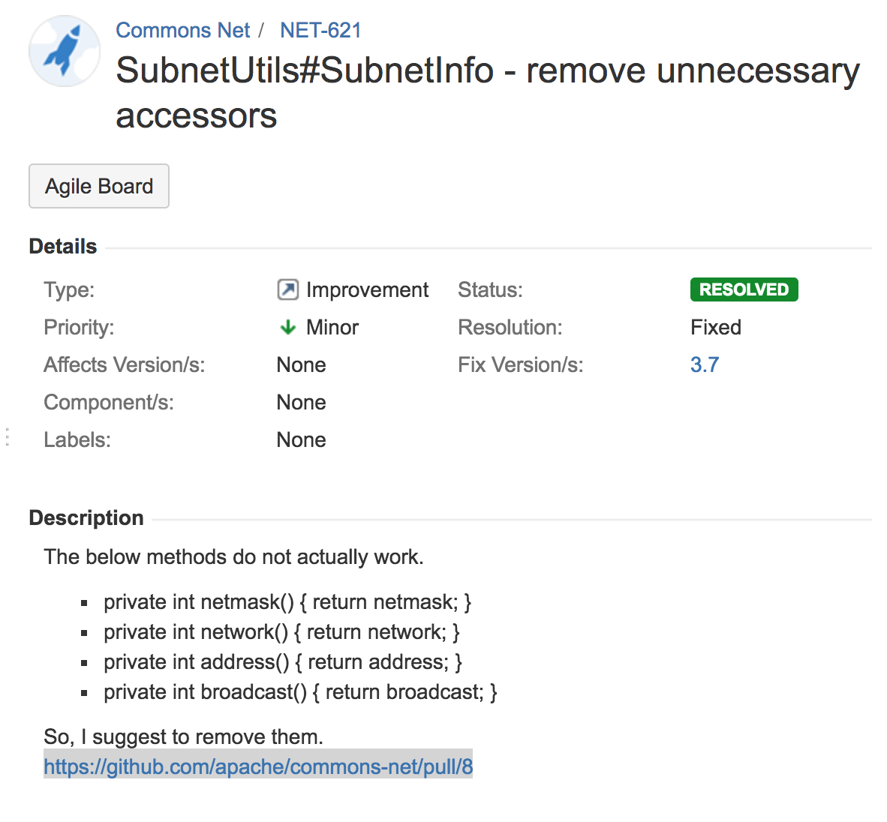

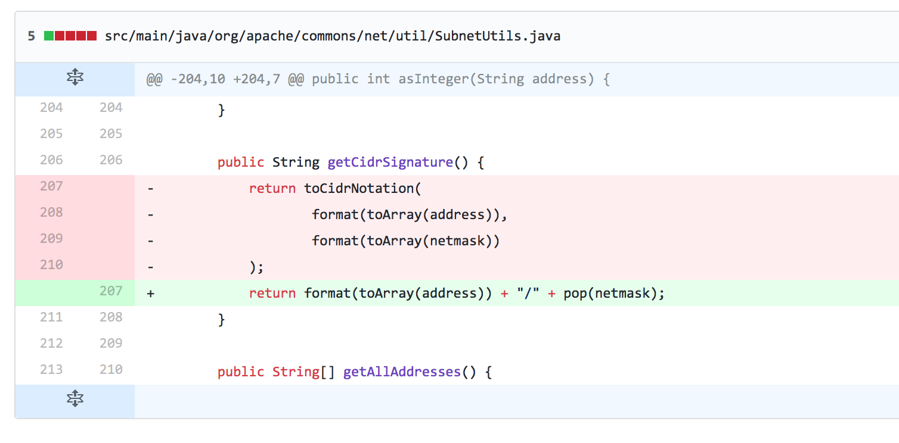

This one is same ahead that is Speculative Generality.